**RETAIL SALES REPORT**

**--Data Analysis and Business key problems and answers**

**--(1) Retrieve all columns for sales made for '2022-11-05'**

select*from retail_sales

where sale_date='2022-11-05'

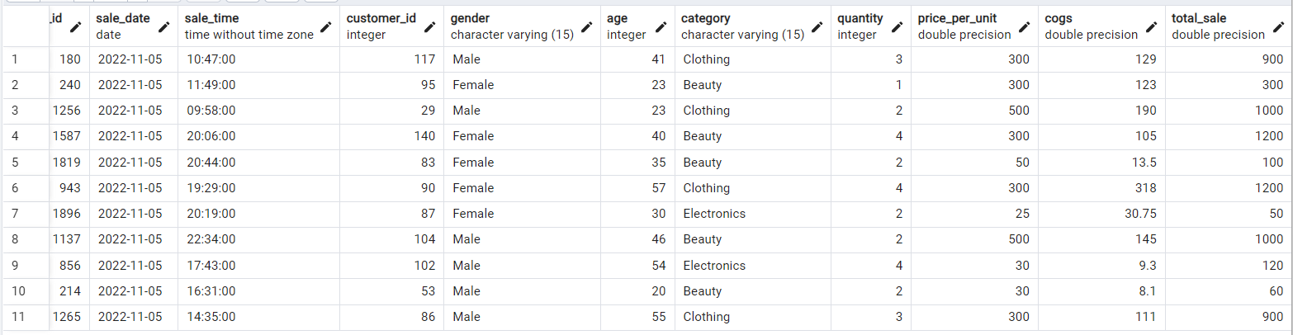

**--(2) Retrieve all transactions where the category is clothing and the quantity sold is more than 4 in the month of nov-2022**

select*from retail_sales

where

category='Clothing'

and

to_char(sale_date,'yyyy-mm')='2022-11'

and

quantity>=4

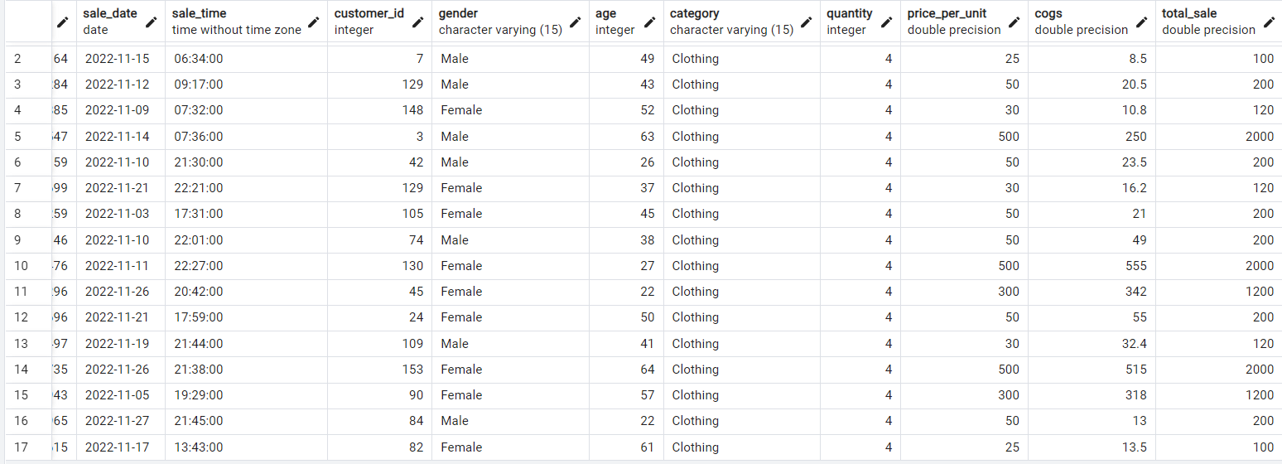

**--(3) calculate total sale for each category?**

select

category,

sum(total_sale)as net_sale,

count(*) as total_orders

from retail_sales

group by 1

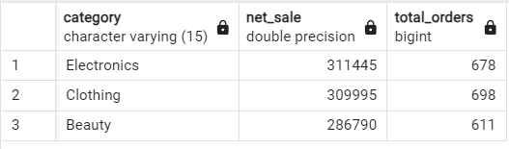

**--(4) calculate the average age of customers who purchased items from the beauty category?**

select

round(avg(age),2)as average_age

from retail_sales

where category='Beauty'

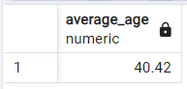

**--(5) find all transactions where the total sale is greater than 1000?**

select

*

from retail_sales

where total_sale>1000

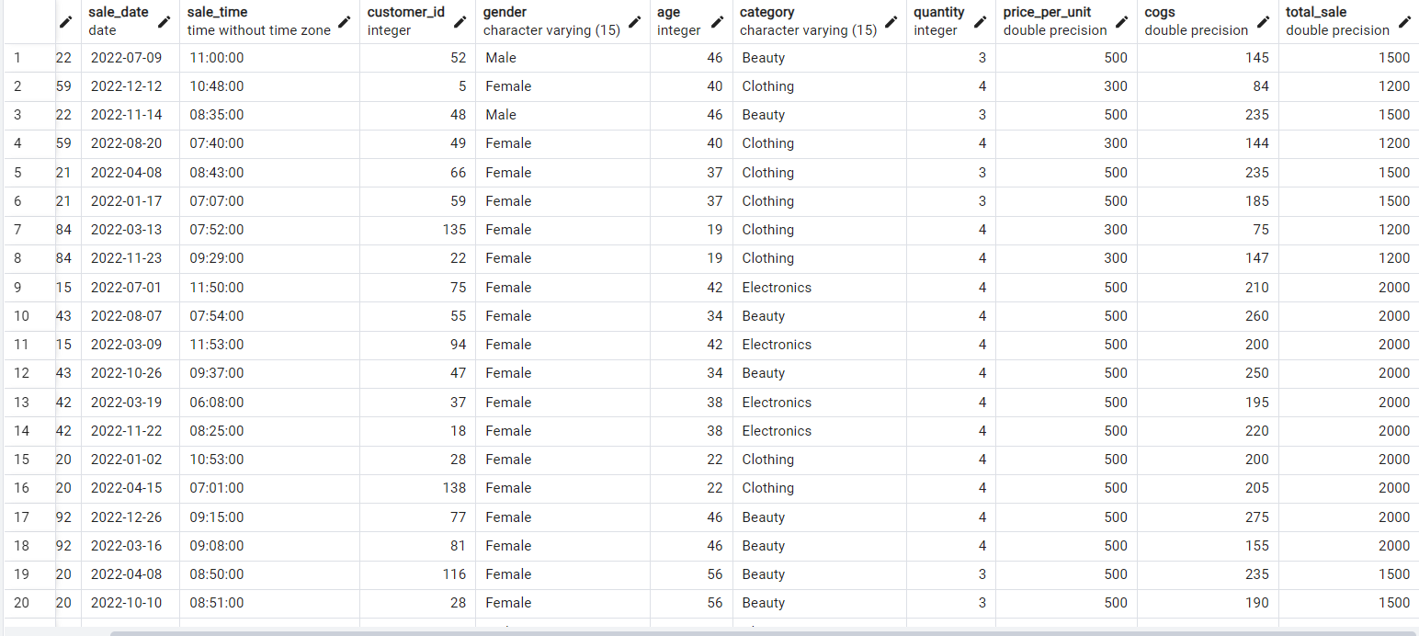

**--(6) find the total no of transactions(transaction_id) made by each gender in each category?**

select

category,gender,

count(*)as total_no_of_transactions

from retail_sales

group by category,gender

order by 1

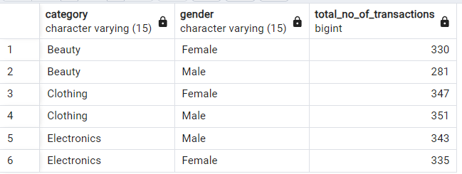

**--(7) calculate the average sale for each month.Find out best selling month in each year?**

select

year,

month,

avg_sale

from

(

select

extract(year from sale_date)as year,

extract(month from sale_date)as month,

avg(total_sale)as avg_sale,

rank()over(partition by extract(year from sale_date) order by avg(total_sale)desc)as rank

from retail_sales

group by 1,2

)as t1

where rank=1

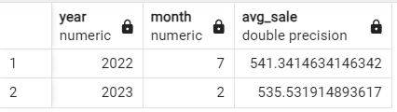

**--(8) find the top 5 customers based on the highest total sales**

select

customer_id,

sum(total_sale)as total_sale

from retail_sales

group by 1

order by 2 desc

limit

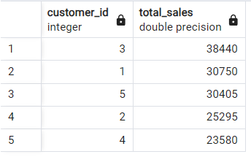

**--(9) find the no. of unique customers who purchased items from each category?**

select

category,

count(distinct customer_id)as unique_customers

from retail_sales

group by 1

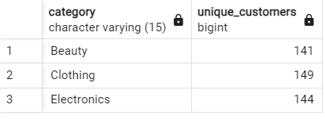

**--(10) create each shift and no of orders (eg morning<=12,afternoon between 12 and 17,evening>17)**

with hourly_sale

as

(

select *,

case

when extract(hour from sale_time)<=12 then 'Morning'

when extract(hour from sale_time)between 12 and 17 then'Afternoon'

else'Evening'

end as shift

from retail_sales

)

select

shift,

count(*)as total_orders

from hourly_sale

group by 1

